AI Parenting Survey

Adam Jauregui

10/17/2019

## TAM and Prob Tech

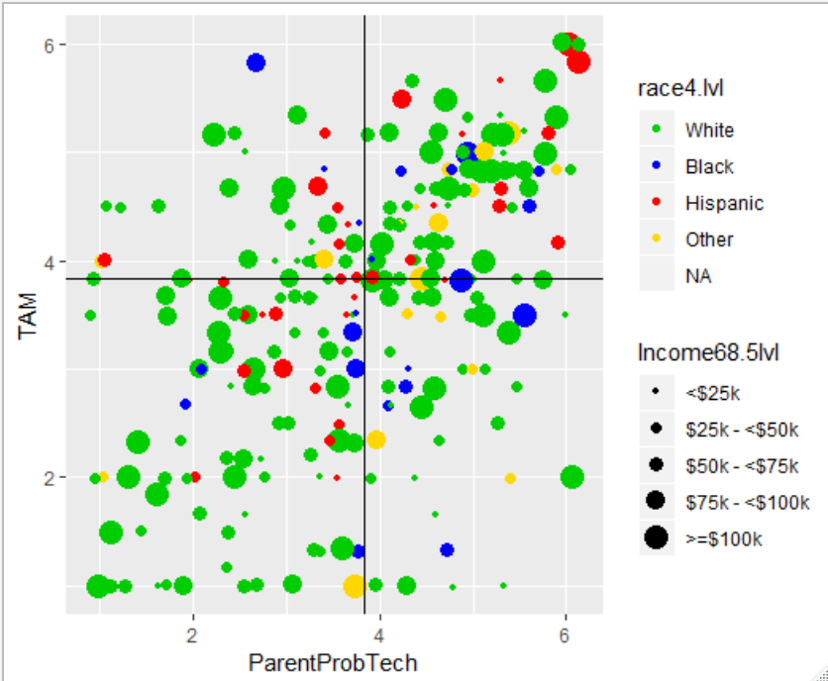

## Table for TAM and Parent Prob Tech

|  |  |  |  |  |  |
| --- | --- | --- | --- | --- | --- |
|  | | TopTamTopPPT | TopTamBotPPT | BotTamTopPPT | BotTamBotPPT |
| **n** | | 101 | 41 | 39 | 99 |
| **TAM (mean (SD))** | | 4.63 (0.58) | 4.35 (0.49) | 2.71 (0.85) | 2.39 (0.93) |
| **Technofere (mean (SD))** | | 3.96 (2.04) | 2.90 (2.11) | 2.36 (1.53) | 2.38 (1.95) |
| **ParProbTech (mean (SD))** | | 4.86 (0.62) | 2.83 (0.84) | 4.67 (0.57) | 2.54 (0.85) |
| **Age (mean (SD))** | | 32.70 (7.23) | 32.12 (9.95) | 31.15 (6.53) | 33.87 (9.45) |
| **Gender (%)** | |  |  |  |  |
| Male | | 26 (25.7) | 7 (17.1) | 4 (10.3) | 20 (20.2) |
| Female | | 74 (73.3) | 34 (82.9) | 35 (89.7) | 79 (79.8) |
| NA | | 1 ( 1.0) | 0 (0.0) | 0 (0.0) | 0 (0.0) |
| **Race (%)** | |  |  |  |  |
| White | | 63 (62.4) | 25 (61.0) | 27 (69.2) | 69 (69.7) |
| Black | | 9 ( 8.9) | 3 ( 7.3) | 6 (15.4) | 6 ( 6.1) |
| Hispanic | | 14 (13.9) | 10 (24.4) | 0 (0.0) | 16 (16.2) |
| Other | | 13 (12.9) | 2 ( 4.9) | 5 (12.8) | 2 ( 2.0) |
| NA | | 2 ( 2.0) | 1 ( 2.4) | 1 ( 2.6) | 6 ( 6.1) |
| **Language (%)** | |  |  |  |  |
| English | | 85 (84.2) | 36 (87.8) | 37 (94.9) | 83 (83.8) |
| Other | | 16 (15.8) | 5 (12.2) | 2 ( 5.1) | 16 (16.2) |
| **Number of Children (%)** | |  |  |  |  |
| >1 | | 64 (63.4) | 21 (51.2) | 25 (64.1) | 62 (62.6) |
| 1 | | 37 (36.6) | 20 (48.8) | 14 (35.9) | 37 (37.4) |
| **Education (%)** | |  |  |  |  |
| HS or less | | 25 (24.8) | 10 (24.4) | 10 (25.6) | 36 (36.4) |
| Some College | | 21 (20.8) | 9 (22.0) | 11 (28.2) | 24 (24.2) |
| College Degree | | 55 (54.5) | 22 (53.7) | 18 (46.2) | 39 (39.4) |
| **Income (%)** | |  |  |  |  |
| <$25k | | 22 (21.8) | 8 (19.5) | 9 (23.1) | 18 (18.2) |
| $25k - <$50k | | 17 (16.8) | 10 (24.4) | 12 (30.8) | 29 (29.3) |
| $50k - <$75k | | 26 (25.7) | 9 (22.0) | 8 (20.5) | 22 (22.2) |
| $75k - <$100k | | 17 (16.8) | 12 (29.3) | 4 (10.3) | 16 (16.2) |
| >=$100k | | 19 (18.8) | 2 ( 4.9) | 6 (15.4) | 14 (14.1) |
|  |  |  |
|  |  |  |
|  |  |  |

## TAM and Technoference

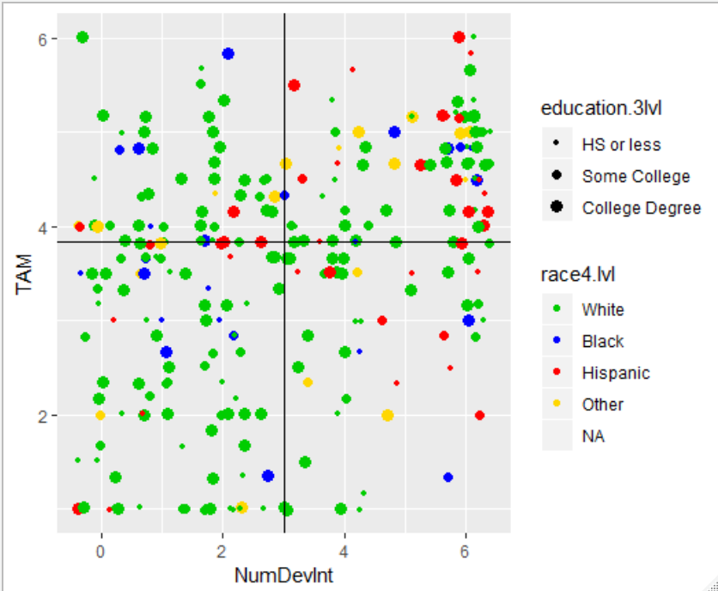

## Tables for TAM and Technoference

|  |  |  |  |  |  |
| --- | --- | --- | --- | --- | --- |
|  | TopTAMTopNDI |  | TopTAMBotNDI | BotTAMTopNDI | BotTAMBotNDI |
| **n** | 93 |  | 49 | 56 | 82 |
| **TAM (mean (SD))** | 4.62 (0.55) |  | 4.43 (0.60) | 2.71 (0.86) | 2.32 (0.93) |
| **Technofere (mean (SD))** | 4.96 (1.22) |  | 1.18 (0.83) | 4.25 (1.16) | 1.10 (0.83) |
| **ParProbTech (mean (SD))** | 4.52 (1.05) |  | 3.82 (1.21) | 3.36 (1.20) | 2.98 (1.25) |
| **Age (mean (SD))** | 31.77 (7.58) |  | 33.98 (8.86) | 32.50 (6.68) | 33.51 (9.99) |
| **Gender (%)** |  |  |  |  |  |
| Male | 22 (23.7) |  | 11 (22.4) | 10 (17.9) | 14 (17.1) |
| Female | 71 (76.3) |  | 37 (75.5) | 46 (82.1) | 68 (82.9) |
| NA | 0 (0.0) |  | 1 ( 2.0) | 0 (0.0) | 0 (0.0) |
| **Race (%)** |  |  |  |  |  |
| White | 55 (59.1) |  | 33 (67.3) | 35 (62.5) | 61 (74.4) |
| Black | 7 ( 7.5) |  | 5 (10.2) | 4 ( 7.1) | 8 ( 9.8) |
| Hispanic | 20 (21.5) |  | 4 ( 8.2) | 9 (16.1) | 7 ( 8.5) |
| Other | 10 (10.8) |  | 5 (10.2) | 4 ( 7.1) | 3 ( 3.7) |
| NA | 1 ( 1.1) |  | 2 ( 4.1) | 4 ( 7.1) | 3 ( 3.7) |
| **Language (%)** |  |  |  |  |  |
| English | 75 (80.6) |  | 46 (93.9) | 46 (82.1) | 74 (90.2) |
| Other | 18 (19.4) |  | 3 ( 6.1) | 10 (17.9) | 8 ( 9.8) |
| **Number of Children (%)** |  |  |  |  |  |
| >1 | 58 (62.4) |  | 27 (55.1) | 36 (64.3) | 51 (62.2) |
| 1 | 35 (37.6) |  | 22 (44.9) | 20 (35.7) | 31 (37.8) |
| **Education** **(%)** |  |  |  |  |  |
| HS or less | 29 (31.2) |  | 6 (12.2) | 16 (28.6) | 30 (36.6) |
| Some College | 18 (19.4) |  | 12 (24.5) | 11 (19.6) | 24 (29.3) |
| College Degree | 46 (49.5) |  | 31 (63.3) | 29 (51.8) | 28 (34.1) |
| **Income (%)** |  |  |  |  |  |
| <$25k | 21 (22.6) |  | 9 (18.4) | 6 (10.7) | 21 (25.6) |
| $25k - <$50k | 16 (17.2) |  | 11 (22.4) | 17 (30.4) | 24 (29.3) |
| $50k - <$75k | 25 (26.9) |  | 10 (20.4) | 15 (26.8) | 15 (18.3) |
| $75k - <$100k | 18 (19.4) |  | 11 (22.4) | 10 (17.9) | 10 (12.2) |
| >=$100k | 13 (14.0) |  | 8 (16.3) | 8 (14.3) | 12 (14.6) |